ooxWord://word/media/image0.binooxWord://word/media/image4.binooxWord://word/media/image5.bin**Investigating Tmdb movie database 2018**

SEPTEMBER 14

**Udacity Data Analyst Nanodegree Authored by: Neha Singh**

**1**

ooxWord://word/media/image6.binooxWord://word/media/image7.binooxWord://word/media/image8.binooxWord://word/media/image9.binooxWord://word/media/image10.binooxWord://word/media/image11.binooxWord://word/media/image12.binooxWord://word/media/image15.binooxWord://word/media/image16.binooxWord://word/media/image17.bin**Project: Investigate a Dataset (TMDb_Movies Dataset)**

**Overview**

For our 2nd Data Analysis project I have opted for the TMDb movies dataset.

**This data set contains information about 10 thousand movies collected from The Movie Database (TMDb), including user ratings and revenue**

**Questions which I analyzed from this database :**

1. Movies, which had most and least profit.

2. Movies with largest and lowest budgets.

3. Movies with most and least earned revenue.

4. Movies with longest and shortest runtime values.

5. Average runtime of all the movies.

6. Year of release vs profitability

7. Average budget of movies which earned $40 million or more

8.Average runtime of movies which earned $40 million or more

**2**

ooxWord://word/media/image18.bin***Used Code:***

***# import required libraries***

import numpy as np import pandas as pd

import datetime from datetime

from matplotlib import pyplot as plt

***DATA WRANGLING***

***# Since this dataset contains a lot of undesired data, we will just weed out the unnecessary columns/data so as to make our calculations easy***

***# loading data from csv file***

movie_data = pd.read_csv(‘tmdb-movies.csv’)

***# after previewing the dataset with .head() function, we came to know that***

***1- there are 21 columns and many of them are unimportant for our observations.***

***2- No currency has been given in the dataset.***

***DATA CLEANING***

***# removing the unused columns***

***# we will delete several unnecessary columns in order to simplify our calculations.***

**3**

ooxWord://word/media/image19.bin***# we will do this by assigning them to an array and then dropping them***

=

useless_col = [ 'id', 'imdb_id', 'popularity', 'budget_adj', 'revenue_adj', 'homepage', 'keywords', 'overview', 'production_companies', 'vote_count', 'vote_average']

movie_data = movie_data.drop(useless_col , 1)

***# checking for duplicates in dataset***

Sum(movie_data.duplicated())

**# dropping the duplicate data**

|  |  |
| --- | --- |
| movie_data.drop_duplicates(keep = = True) | ‘first’ , inplace |

**# *creating a seperate list of revenue and budget column so as to remove 0's from these series***

change_list = ['revenue' , 'budget']

***# replacing all 0's with NAN'***

movie_data[change_list] =

movie_data[change_list].replace(0 , np.NAN)

***#dropping NAN***

movie_data.dropna(subset = change_list , inplace

True)

***# replacing the 0 values of runtime column with NAN***

movie_data['runtime'] =

movie_data['runtime'].replace(0 , np.NAN)

**4**

ooxWord://word/media/image20.bin*# Checking the datatypes of the given dataset*

movie_data.dtypes

budget float64 revenue float64 original_title object cast object director object tagline object runtime int64 genres object release_date object release_year int64 dtype: object

***# since the budget and revenue columns is in float, we will change it to int***

change_dtype = ['budget' , 'revenue']

***# changing the datatype to int***

movie_data[change_dtype] = movie_data[change_dtype].applymap(np.int64)

***Data Analysis***

***3-* Calculating the profit of each movie**

***# for this we are going use the function insert to create a new column called profit_earned***

movie_data.insert(2 , 'profit_earned' , movie_data['revenue']-movie_data['budget'])

**5**

ooxWord://word/media/image21.bin**Question 1- Which movies had the most and least profit?**

***# we are going to define a function for gettig the answer to this question***

def calculate_max_min(column):

highest_profit_id = movie_data[column].idxmax()

highest_profit_id_details = pd.DataFrame(movie_data.loc[highest_profit_id])

lowest_profit_id = movie_data[column].idxmin()

lowest_profit_id_details = pd.DataFrame(movie_data.loc[lowest_profit_id])

***#collecting data in one frame***

show = pd.concat([highest_profit_id_details , lowest_profit_id_details] , axis = 1) return show

***# calling the function***

calculate_max_min('profit_earned')

**The results show that AVATAR had the highest profit while THE WARRIOR**’**S WAY had the lowest profit**

**6**

***Question 2- which movies had the largest & smallest budget?***

calculate_max_min('budget')

**The results show that THE WARRIOR**’**S WAY had the largest budget while LOST & FOUND had the smallest budget**

***Question 3- which movies earned the largest & smallest revenue?***

calculate_max_min('revenue')

**7**

ooxWord://word/media/image22.bin**The results show that AVATAR earned the largest revenue while SHATTERED GLASS earned the smallest revenue**

**Question 4- movies with longest and shortest runtime?**

calculate_max_min('runtime')

**The results show that CARLOS had the longest runtime while KID**’**S STORY HAD the smallest runtime**

**8**

**Question 5- average runtime of all movies**

def **average_run(column):**

return **movie_data[column].mean()**

***# calling the function***

average_run('runtime')

**The results show that all movies had an average runtime of 109.22 minutes**

**9**

**We also plotted a histogram, a boxplot & a swarmplot to get a bigger picture of runtime of all movies.**

**Since visualisation often helps in better , fair and more beautiful communication of results , We have also included a line plot between Year of release and total profitability so as to check which year has given us the most profits.**

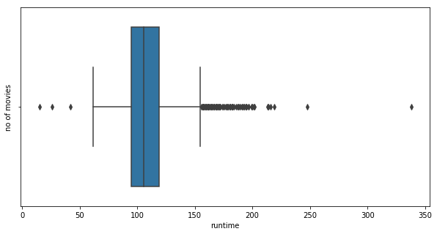

ooxWord://word/media/image23.bin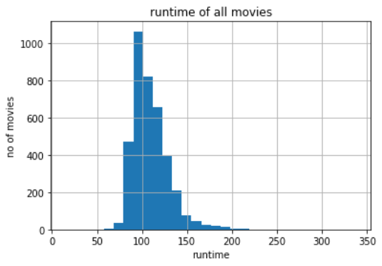**10**

***Another data point plot of runtime of movies:***

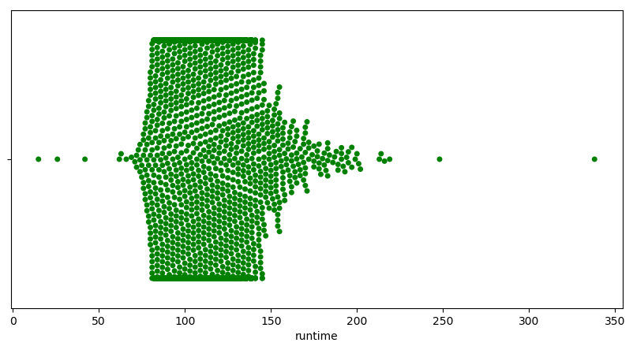

***The swarmplot generated above provides a complete visual of runtime of movies by plotting the points against their respective positions in the distribution.***

***Whereas, the boxplot provides us with an idea about how spreaded our distribution is in case of the runtime of the movies. It also provides us any outliers which are present in our data.***

***The bar graph is right skewed, i.e most of the movies are timed between 80-115 mnutes. There are almost 1000 movies which fall into this criteria.***

***11***

ooxWord://word/media/image26.binooxWord://word/media/image27.binooxWord://word/media/image28.binooxWord://word/media/image29.binooxWord://word/media/image30.binooxWord://word/media/image31.binooxWord://word/media/image32.binooxWord://word/media/image33.binooxWord://word/media/image34.binooxWord://word/media/image35.binooxWord://word/media/image36.binooxWord://word/media/image37.binooxWord://word/media/image38.binooxWord://word/media/image39.binooxWord://word/media/image40.binooxWord://word/media/image41.binooxWord://word/media/image42.binooxWord://word/media/image43.binooxWord://word/media/image44.binooxWord://word/media/image45.binooxWord://word/media/image46.binooxWord://word/media/image47.binooxWord://word/media/image48.binooxWord://word/media/image49.binooxWord://word/media/image50.binooxWord://word/media/image51.bin***We also used the .describe() function on the runtime column and with the help of this + the above visualisations, we can say that:***

***25% of the movies had a runtime of less than 95 minutes***

***50% of the movies had a runtime of less than 106 minutes***

***75% of the movies had a runtime of less than 119 minutes***

***12***

***Question 6- Which year saw the most profits(combined) ?***

***For this we generated a line plot between year of release & profitablity***

***# year of release vs profitability***

profits_earned_per_year = movie_data.groupby('release_year')['profit_earned'].sum()

plt.figure(figsize = (10 , 5) , dpi = 100)

plt.plot(profits_earned_per_year)

plt.legend()

plt.xlabel('total profits')

plt.ylabel('year of release')

plt.show()

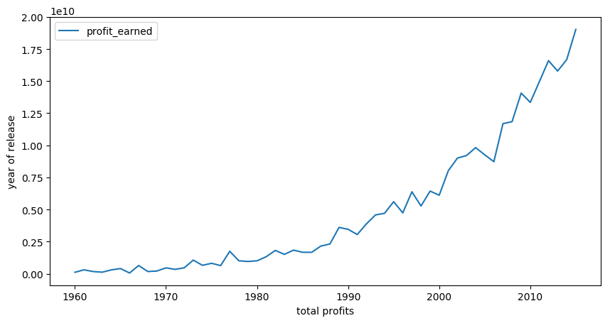

**So we can graphically conclude that year 2015 was the time when movies made the most profit.**

***Now let***’***s analyse our data in the light of the fact that we will consider only those movies under the profitable category which have earned a profit of more than $ 40 million***

***So we will clean out our data once again using the following code-***

most_profitable_movies = movie_data[movie_data['profit_earned']

>=40000000] most_profitable_movies.index =

range(len(most_profitable_movies))

14

**Question 7- average budget of movies earning $40 million or more?**

***# we will define another function for calulating the avg. budget***

def avg_profit(column):

return most_profitable_movies[column].mean()

# We called the above function on :

avg_profit('budget')

**Movies, which earned $40 million or more, were on an average budget of $57308877**

**Questiom 8- average runtime of movies earning $40 million or more?**

# average duration of most profitable movies

avg_profit('runtime')

**Movies, which earned $40 million or more, had an average runtime of 113 minutes**

**15**

**Limitations and Conclusions**

ooxWord://word/media/image52.bin

**Conclusions:**

 **Average runtime of a good movie should be around 113**

**minutes**

 **Average budget should be around $57 million**

**If one follows the above guidelines, his/her movie can become one of the hits and can earn a revenue of $236306323 or more**

**Limitations:**

 **The database hasn**’**t been updated from a long time**

**which resulted in a decreased accuracy of the results**

 **The currency we took in our case i.e $ might be not**

**the same for movies produced in different countries.**

**Morever, it dosen’t accounts the money for inflation occurred all these years. All this may result in a completely different picture of the whole data.**

ooxWord://word/media/image57.bin

**References:**

1. **Stackoverflow.com for excellent material on idmax() & idmin() functions.**

**2- Python documentation for insights on all the used functions.**

**3- DataCamp.com for basic ideas on functions.**

**11**